**Project 1**

Qiang Qin UFID:99696682

* How do you intend to procure the data?

I have downloaded MNIST dataset from website <http://yann.lecun.com/exdb/mnist/>. I will use this handwriting dataset firstly and use other datasets (maybe handwriting letters) later.

* What programming language/platform/library/packages do you intend to use for the project?

I will use python 3.7.3 on Windows 10.0 version18363. As for library and packages, I will use Pytorch 1.3.1, CUDA 10.1 and cuDNN 7501.

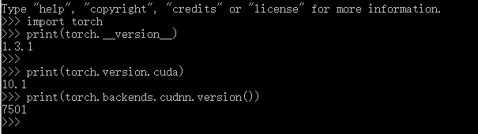

* What computational resources will you use (your own laptop/dept machine/something in the cloud)?

I will use my own PC (with RTX 2080 and i7-9700K) to finish this project.